|  |  |  |  |  |  |  |  |  |  |
| --- | --- | --- | --- | --- | --- | --- | --- | --- | --- |
|  |  |  | **CL117** | | |  |  | **LAB 04** |  |
|  | I |  |  |  |  |  |  |  |
|  | **INTRODUCTION** | | | | |  |
|  |  |  | **Windows Command Prompt** |  |
|  |  |  |  |  |  |  |  |  |
|  | **TO ICT** | | | | |  |
|  |  |  |  |  |
|  | | | | | | |  | |  |
| **NATIONAL UNIVERSITY OF COMPUTER AND EMERGING SCIENCES** | | | | | | | | |  |

Today’s lab consists of:

Learning how to use Windows’s command line tools to organize, manage, and navigate to files

**History of the Command-Line Language:**

Before there was Windows... there was the Microsoft Disk Operating System commonly referred to as MS-DOS. There was also a popular operating system called UNIX, but it was more popular with scientists and supercomputer users, while many of the “ordinary folk” used MS-DOS. Whereas Windows has a lovely graphical user interface, DOS was all done with text commands. That is, you typed out what you wanted the computer to do. Later the Windows operating system was built on top of DOS, so that DOS commands would run in the background, corresponding to how one interacted with the graphical interface. For example, if you click and dragged a file to a folder to move it, Windows would literally run the corresponding move command in DOS. Something similar to DOS still lives on in Windows 10, and that is what we'll be looking at today.

**Windows Command Prompt:**

So, how do we start giving text commands to Windows? First, we need to open the command prompt (or prompt for short). Click on the Windows Start Button, then search for “cmd” in the Search box and click on the program cmd.exe that appears in the search list. A cheery black and white window should pop up. Notice there are no menus! Click in the Command prompt window to begin entering commands.

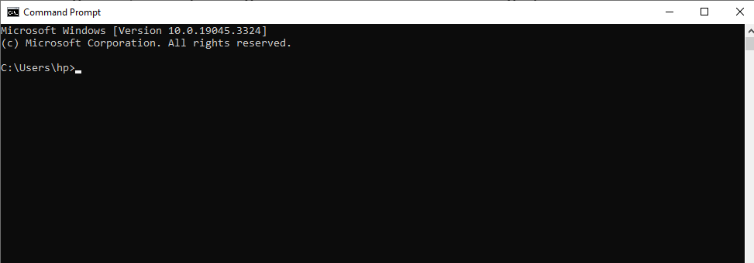

**The prompt:**

The “prompt” is the text that appears on the screen before a blinking “_” (underscore) character. The default prompt is the Drive letter and Path of your current location on the computer, in this case, it is your I drive followed by a “>” (the greater-than sign just separates the prompt from the text you enter). Notice the prompt C:\>. A prompt sits there and waits, telling you that the COMMAND processor is expecting you to enter a command. This is a rather boring (but useful) prompt, which we can change to something more interesting if we like. We'll learn that later. You may find a path other than your I drive. It is totally fine!

**The color command and getting help:**

First, notice the console has some very basic colors: black background with white foreground color. Using the color command, we can alter these colors to suit our taste. To find out how to use the color command (or any command, for that matter),

**type color /? and hit enter**:

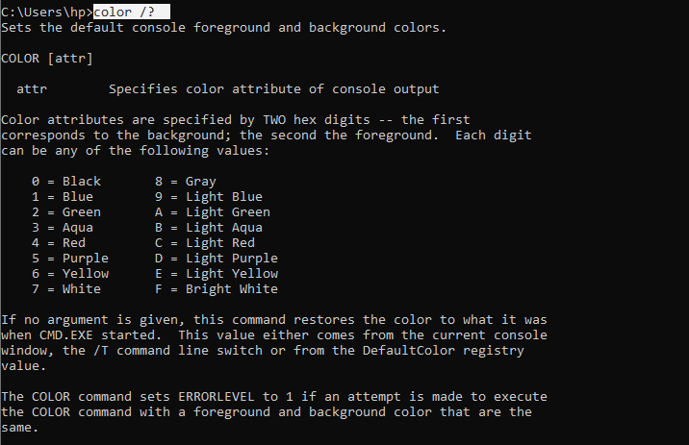Next, we need to know how to read the help text. The very first line defines what the command does, and the second line shows what you need to type to get it working. The special notation COLOR [attr] means that the command name color is mandatory, but the attributes after the command word are optional. Anything optional has brackets [ ] wrapped around it in the help text. Don’t actually type the brackets. They're just informative, saying, anything you type after the command word color is optional. The help text afterwards explains how to set the attributes. Read the rest of the color help text and see if you can set the console background to blue and the foreground color to light green. (Hint: in this case, it might be easier to think of these “hex digits” it talks about as just symbols. The symbols range from 0-9 and from A-F. The help text explains what each symbol represents. The very last line of this help text gives you a useful example to see how the use of these hex digits work with the color command.)

Try a few color combinations until you find a combination you like. Or you can set it back to black and white if you don't like the colors.

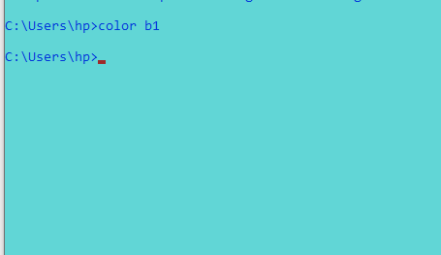

**Changing drives:**

Data stored on a Windows machine is divided into drives, folders, and files. Drives normally represent physical disks, but there are also network drives which are provided by a remote server. For this exercise we need to create some new files and folders. We shouldn’t alter the contents of the C: drive, but we can certainly list out what files and folders are on the C: drive. To change from C: drive to another, we type in the drive letter followed immediately (no space) with a “:” (colon). For example, we need to change drives from the C: drive to the D: drive. Just type D: and you now see the prompt tells us we're on the D: drive now. If you were already in the D drive you don’t need to type D:



**The DIR command:**

To list out all the files and folders that are inside of a folder (or “directory”), we use the dir command. Since this is a new command to us,

type dir /? to get help on the usage of this important command. There are lots of options! Note that all the parameters are optional (shown in square brackets). This means you can use the dir command verb all by itself. Type dir --and you will see a listing of all the files and directories in your prompt is currently in. The dir command by itself lists the contents of whatever folder we are in. Since we are in the Windows directory of the C: drive, it lists all files and folders in there. From where we are, if we wanted to list the contents of another drive, say the I drive, we'd type dir D:

Formatting dir's output. Look at the dir /? help text and then type a command that makes the directory listing appear in “wide” format. You should find that /W used with the dir command will give you the directory listing, as listing of all files and folders in that directory in wide format. Try it. dir /W

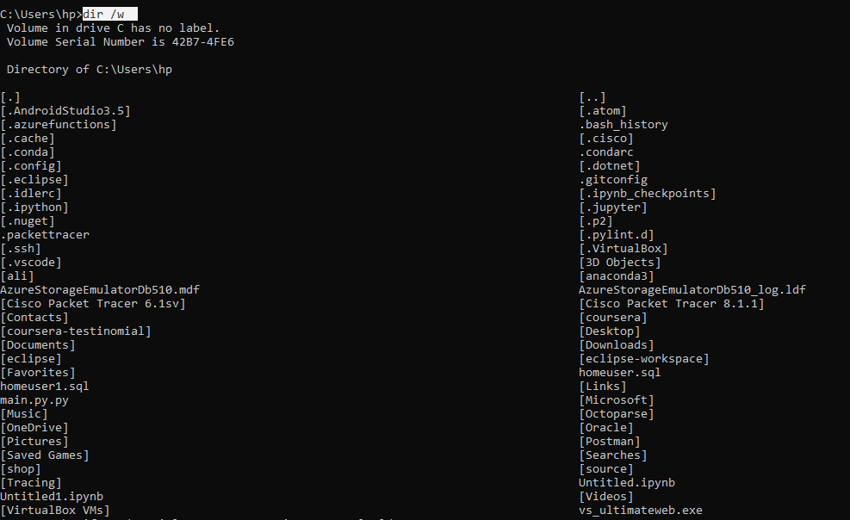

**Making and removing a folder:**

Let’s make a new folder to contain your work. The mkdir command (or just md for short) creates a new directory, also known as a folder. To get help on how to use the mkdir command, type mkdir /? You will see that the usage is simple: the command verb mkdir, followed optionally by a drive name, followed by the path of the directory you wish to make. OK, let’s make a directory named “ALI RIZVI”: mkdir ALI RIZVI Windows responds by giving you another command prompt. There were no error messages, so Windows believes it has correctly carried out your command. Just to make sure, let’s list the contents of our current location:



dir You will see that Windows actually created two new directories, one named “ALI” and the other named “RIZVI”! This is a handy shortcut for when we wish to make more than one folder at a time,

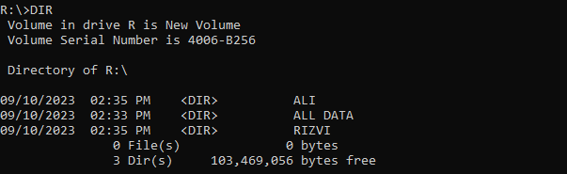

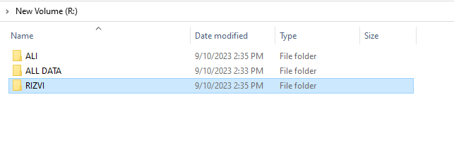but at this time, this isn’t what we wanted, so let’s remove the directories (rmdir or just rd followed by the folder name will remove the folder):

**rmdir ALI**

**rmdir RIZVI**

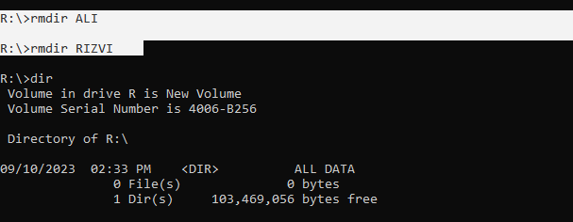By listing the directory contents again using the dir command, you should see that the unwanted directories have been removed. In order to clue the command interpreter into the fact that both “ALI” and “RIZVI” are part of the path name, you need to surround them with quotes.

**Moving to another directory:**

Another fundamental command is the change directory or cd command. The cd or chdir command changes directories, or moves you from one folder to another. Type cd /? to get help on the usage of this command.

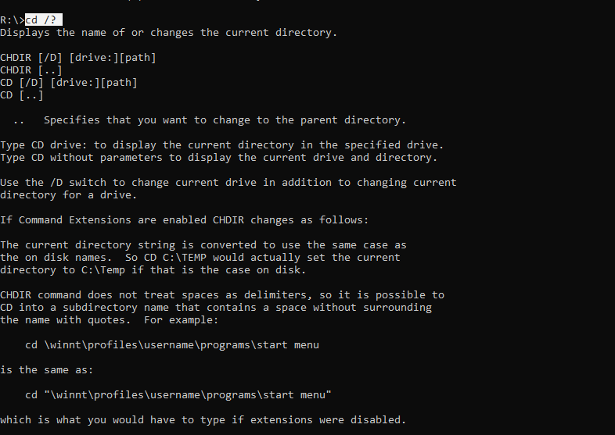

Type cd your directory –

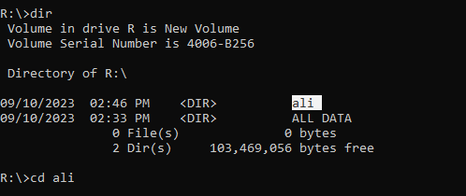

where your directory is the directory you just created (you may need to use double quotes around your directory name). Notice you moved into the subdirectory called your name. For example, typing cd foldername moves you down into a subfolder called foldername (obviously, we don't have a folder called foldername, so don't actually type this in). What if you wanted to go back up one directory level? Type in the dir command again. Thus if we want to move up a directory level, we just change directories to the parent directory by typing cd .. just as if “..” was the name of a folder. Now we're back in the root directory of our One drive. Before going further, let's change directories back to your directory. cd your directory

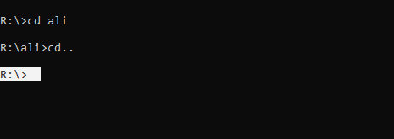

**Creating Subdirectories:**

You should now be in your personal directory located in your drive, and the command prompt should give you the path to your current working directory.

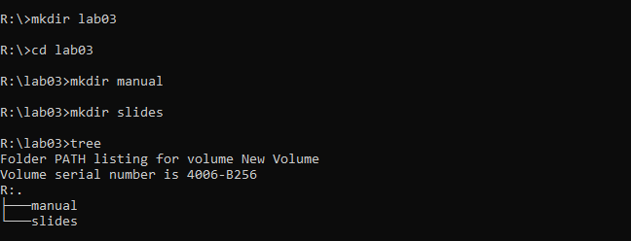

**Capturing Output to a file:**

If any command gives output to the console, you can redirect it into a text file. Here's how: Suppose we wanted to capture the output of the dir command to a filename called DirOutput.txt. All we need to do is add the “>” symbol (the greater-than sign here is the “redirector”) and then the filename to the end of the dir command like so: dir > DirOutput.txt



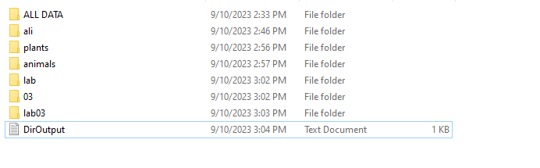

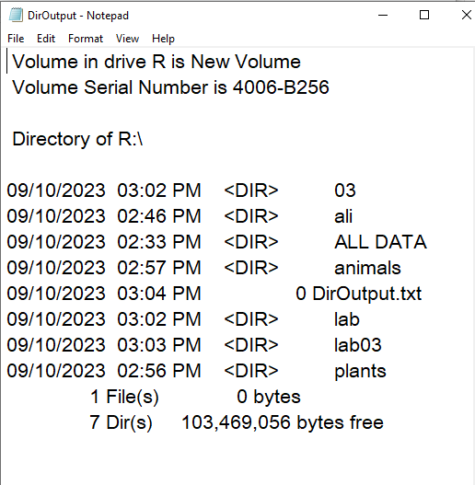

**Viewing Files:**

You can also view the contents of this text file using the type command. Enter **type DirOutput.txt** –

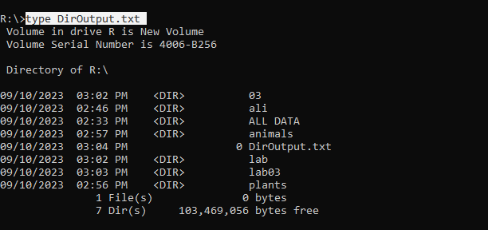 to see the contents of this file. However, this only works for text files! Try displaying an Excel or Word file such as one of your excel exercise files. (You will need to enclose the file name in quotes if it contains a space.) You will see only garbage. Recall from the lecture that an Excel document file is stored in a file format that can only be interpreted by the Excel application program

**Deleting files, directories or an entire directory tree:**

The del command deletes files, and the rmdir command deletes directories. Make sure you are in the directory which contains the file, and type del filename* -- using the wildcard character “*” to avoid typing the full filename.

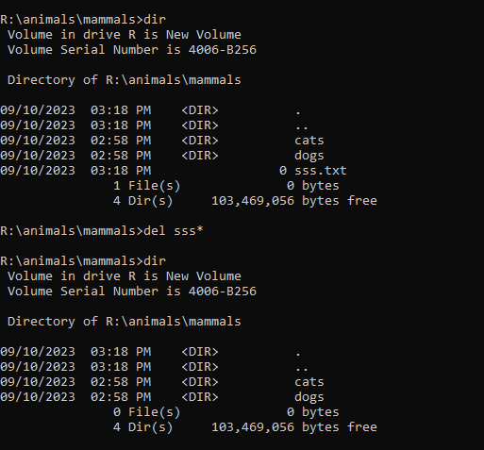

rmdir mammals-- this fails because the mammals directory is not empty. You could go into mammals and clean it out. Instead, type rmdir /S mammals-- and answer Y at the prompt. As you can see, the /S switch for the rmdir command is very powerful, and with great power comes great responsibility. This command must be used with great caution since it can delete many things at once.

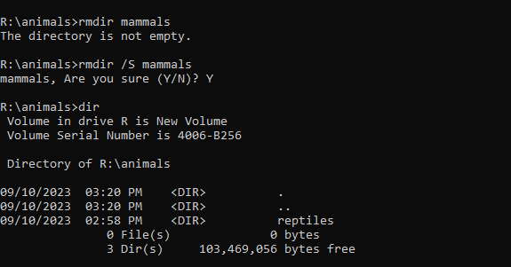

**Useful networking commands:**

Use the command **ipconfig /all** to see the computer’s IP address and other info that would be interesting if you knew what it all meant! Don’t worry; we’ll be explaining this later on. This command is useful for debugging network problems.

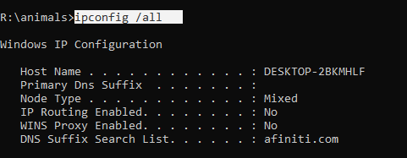

Here are some other useful commands to try:

**ping google.com**

–the ping command sends a probe message out to the remote computer, to see if it is possible to connect, and if so how long it takes for the response to return. You should find that the response is so quick that it is recorded as less than 1 ms (milliseconds).

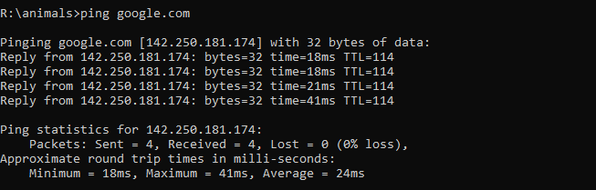

this output indicates that your computer successfully communicated with Google's servers (IP address 142.250.181.174) by sending 4 packets without any packet loss. The response times varied, with the fastest being 18ms, the slowest being 41ms, and an average response time of 24ms. These response times are measures of the latency or delay in the network communication between your computer and Google's servers. Lower response times are generally better for network performance.

**Big list of commands:**

Type **help** and you get a big honking list of commands you can play with on this computer.

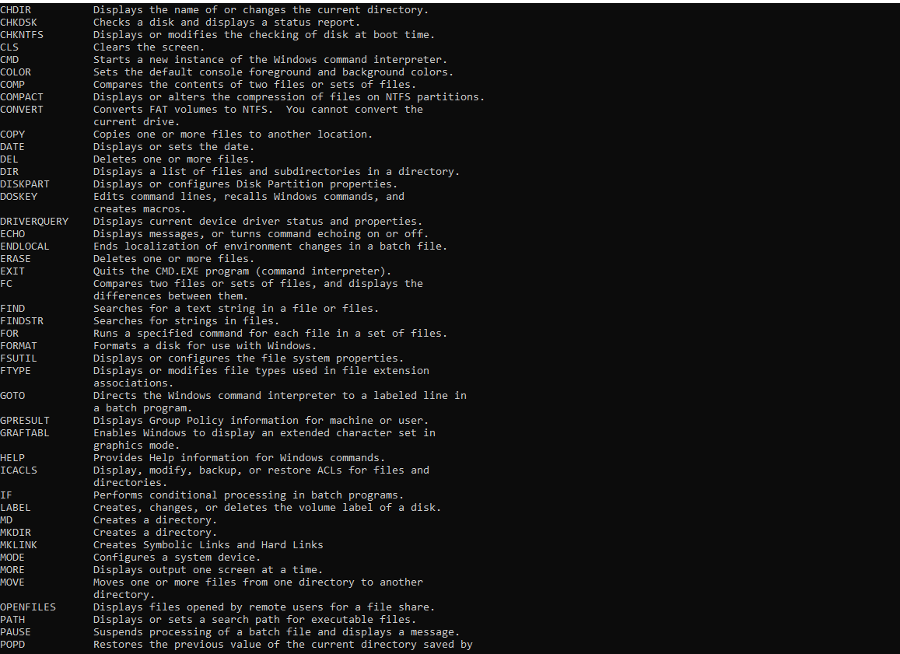

**Systeminfo:**

Check out some of the information you receive. (You probably have to scroll up a long ways). Look at what the computer is called (the Host Name), check out the last time your computer has been rebooted (System Boot Time), check out the processor speed (Processor(s)). This command outputs a long list of information about your computer:

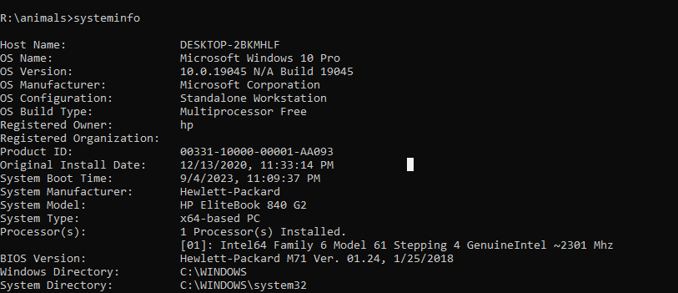

**The where command:**

This is a cool little command that will allow you to find the locations of some files or programs on your computer. For example, to find where notepad is located, type in where notepad

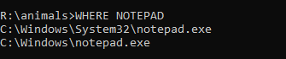

**The prompt command**. To change the prompt text, we use a command called Prompt (yes it gets confusing, but the command Prompt changes the text that appears before the blinking “_” cursor).

To find out how to use the command, **type Prompt /?** in the window. This time, we get a list of options for changing our command prompt. Remember the special notation PROMPT [text] means that the command word prompt is mandatory, but the text after the command word is optional.

To see how this works, **type Prompt Hello, dear**

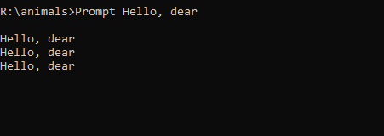

--you will see the Command prompt change to “Hello, dear”! This is actually pretty ugly because it’s hard to tell where the prompt ends and your command begins. We typically like to end our prompt with the “>” sign. Note from the help output that for this command, the “>” sign has a special symbol, $G.

Try entering the command this way: **Prompt Hello, dear$G**



--this time you will see a nicer looking prompt.

To return the prompt back to normal just type:



Congratulations! This completes your introduction to the Windows command prompt. Of course there are greater depths for the truly curious. You should be comfortable using the fundamental commands of dir, cd, and mkdir, and you should also be comfortable using the help menus for the commands.

**TASKS:**

**TASK 1:**

Create two directories named PLANTS and ANIMALS. Change directories to PLANTS, and create the directories HERBS, TREES, and VEGETABLES. Continue until you have created the following directory tree structure:

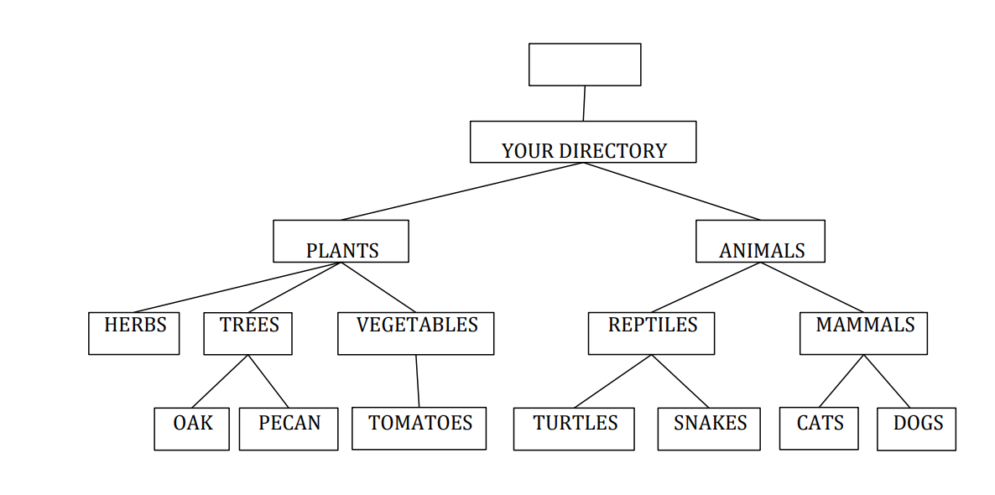

After that type command tree:

It should give output like that:

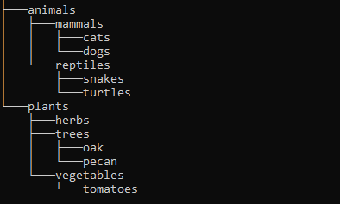

**TASK 2:**

Use the command to display your computer's network configuration. Take note of your IP address, subnet mask, default gateway, and DNS server information.

**TASK 3:**

Ping nu.edu.pk to ping the University website. Take note of the responses, including response times.

**TASK 4:**

View detailed information about your computer, including the host name, system boot time, and processor speed.

**TASK 5:**

Use the command to find the location of the Calculator program on your computer.

**TASK 6:**

Use the command to change your command prompt text to your NU ID.